Peter Schroth & Josette Urso
One View / Two Visions II – Ireland

March 6 – 31, 2023
Reception: Friday, March 24, 5:30 – 7:30 pm
DFN Projects
16 E 79th St, Ground Floor, G-2
(between Madison and 5th Avenues)
New York NY 10075
(212) 884-8040‬‬‬‬‬‬‬‬‬‬‬‬‬‬‬‬‬‬‬‬‬‬‬‬‬‬‬‬‬‬‬‬‬‬

Hours: Monday – Friday, 11am – 4 pm (Closed Saturday & Sunday)

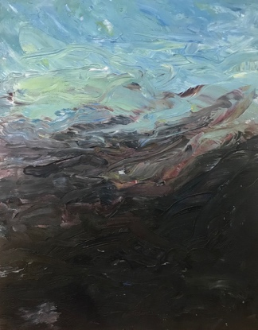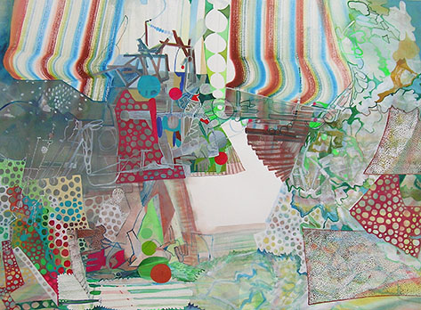

Painters Peter Schroth and Josette Urso share substantial commonalities in general approach while ultimately pursuing different ends. Both artists work intuitively, from subjects observed and reformulated, marrying the environment with their individual interests and temperaments. Schroth’s view is interior, introspective and intimate; Urso’s looks outward, into the relationships between paint and space, subject and imagination. Schroth sees the natural environment as an embodiment of daily human experience. The work deals with time as ongoing, incremental and quietly, discreetly tumultuous. Urso works with an attitude of investigation and release; urgent but not anxious, the brush and eye playing an alternating game of lead and follow while reacting to rolling, real-time impressions.

This exhibition features works created during their 2022 joint fellowship residency at the Ballinglen Arts Foundation, in Ballycastle, County Mayo, Ireland.

Peter Schroth has shown widely in public and private institutions including the Jersey City Museum, Morris Museum, Drawing Center, Lower Manhattan Cultural Council, Lyman Allyn Museum, and Aljira in Newark, NJ. He has been awarded artist grants and fellowships including those from the Pollock-Krasner Foundation, Ballinglen Arts Foundation, MacDowell Colony, Loft Nota Bene, Millay, Art Matters, Elizabeth Foundation, Ucross and Yaddo. He has a BFA from Syracuse University and an MFA from the University of Colorado in Boulder. www.peterschroth.com
Josette Urso has exhibited widely in the United States and abroad at venues including the Bronx Museum of the Arts, Drawing Center, Tampa Museum of Art, Museo de las Americas in Puerto Rico, the Art & Embassies Program and the New York Public Library. She has been the recipient of artist grants and fellowships including, the Pollock-Krasner Foundation, Ballinglen Arts Foundation, Adolph and Esther Gottlieb Foundation, Ruth and Harold Chenven Foundation, Basil H. Alkazzi, Loft Nota Bene, Millay, VCCA, Camargo, Ucross and Yaddo. She has a BFA / Drawing and an MFA / Painting from the University of South Florida in Tampa. www.josetteurso.com
The artists thank the Ballinglen Arts Foundation and Markel Fine Arts who made this endeavor possible and acknowledge the support of Sears-Peyton Gallery.

For more information about Josette’s work contact: Abbie Knight, abbie@markelfinearts.com (212) 366-5368‬‬‬ ‬‬
and for Peter’s work contact: schrothpeter@gmail.com

Left Image: Peter Schroth, “6A”, 2022, oil on canvas mounted to panel, 14 x 11 inches
Right Image: Josette Urso, “Woods Talk”, 2022, watercolor on paper, 22 x 30 inches (Courtesy Markel Fine Arts)

